COMPUTER NETWORK LAB 1

NAME:
MUHAMMAD TALHA
ROLL NUMBER:
241890
CLASS:
4/A
DATE:
2/2/26
INSTRCUTOR:
MR MUHAMMAD BILAL

MIAN SYSTEM:
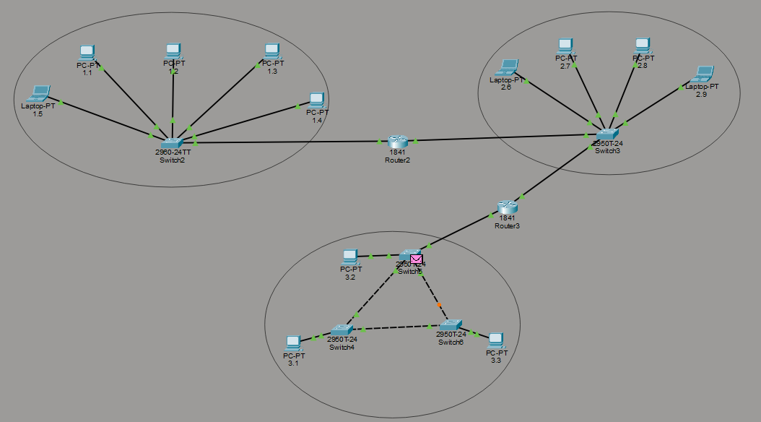
END DEVICES:
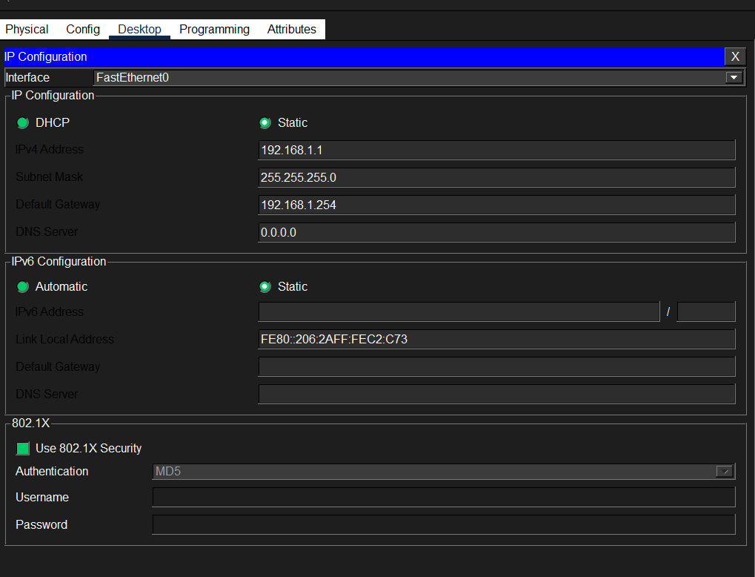
- To give an Ip to an end device, we tap on the device icon and go to desktop and in there we look for Ip adder
- To connect two same devices, we use solid wire whereas to connect tow different device as pc and switch(2960-24tt) we use strip wire
- to check ping, we open the cmd in same way as we opened the Ip adder and then use command: ping 192.168.1.1(Ip of another device) same foe to find the Ip of current device we use ipconfig
NETWORK DEVICES
Include devices such as switches and router etc that are used to connect end devices in a topology
End devices to switches:
To connect the end devices to switches we simply take a wire and connect both
Switch to switch:
To connect a switch to switch we use a router without it we cannot connect to switches
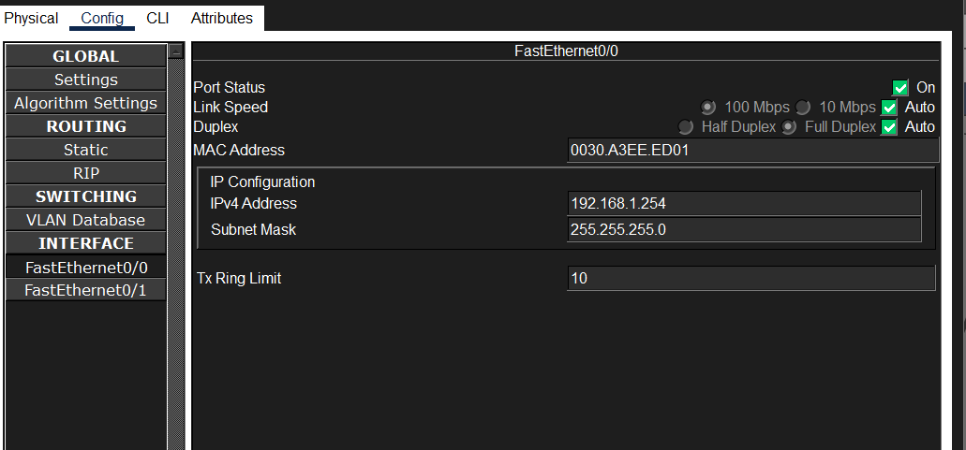
- First, we give it an Ip as shown above then use it
- We also add this Ip to the end devices connected to the switches
- Fast ethernet 0/0 is used for lest and 0/1 for right
